## Skill-React

**React Hands-on Lab: BlogApp**

# Code:

## Terminal Instructions:

**# 1. Create a new React app named "blogapp"**

**npx create-react-app blogapp**

**# 2. Navigate into the project directory**

**cd blogapp**

**# 3. Open the project in Visual Studio Code**

**code .**

**# 4. Start the development server**

**npm start**

# Codes:

## Post.js:

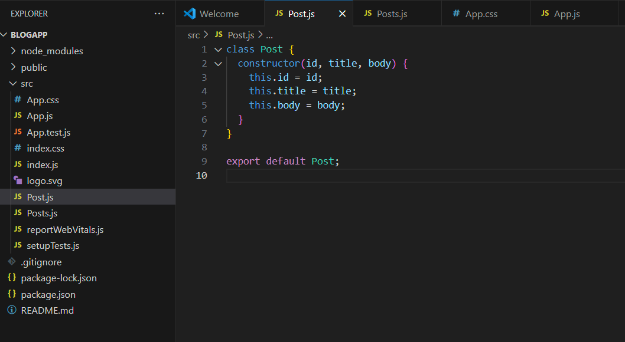

## Posts.js:

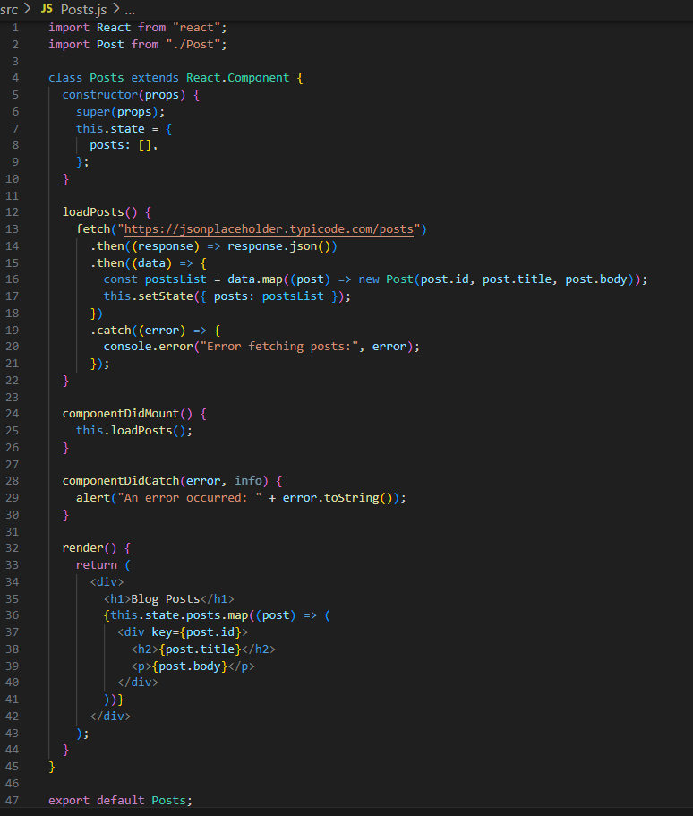

## App.css:

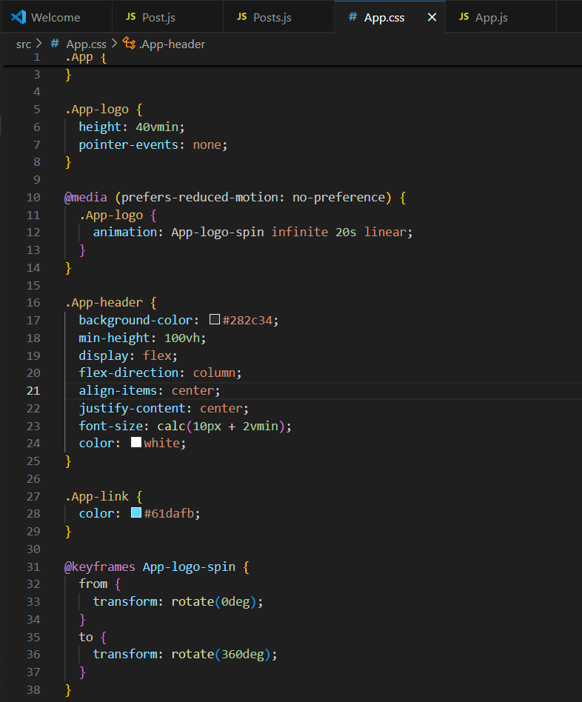

## App.js:

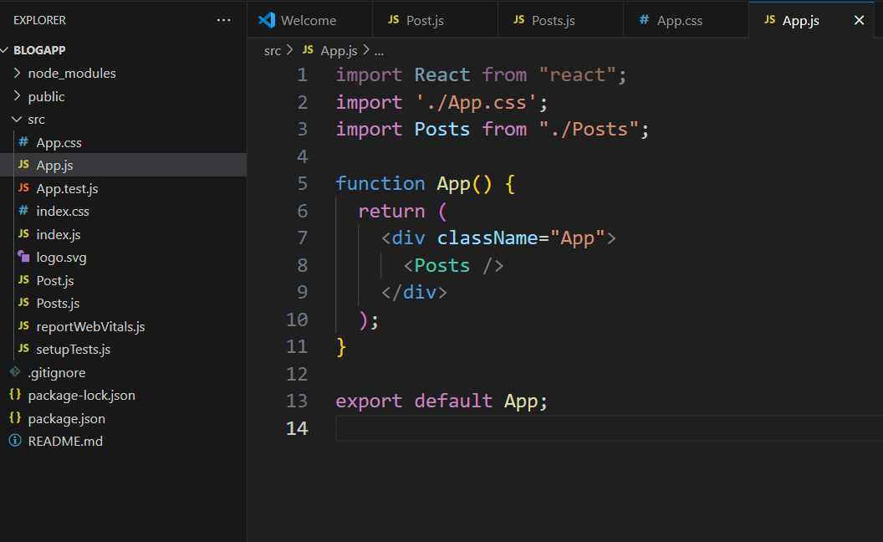

# Output:

